**Calculating Family Expenses Using Service Now**

**Team ID : NM2025TMID48770**

**Team Size : 4**

**Team Leader : D SAMSON JONES**

**Team member : BOOBATHI E**

**Team member : G BALAJI**

**Team member : V JAYASRIDHAR**

**ACTIVITY 1 : CREATION OF NEW UPDATE SET**

**1 . Go to all > filter search for Local Update**

**Set .**

**2 . Click new**

**3 . Enter detail name : Family Expenses**

**4 . Submit and make current**

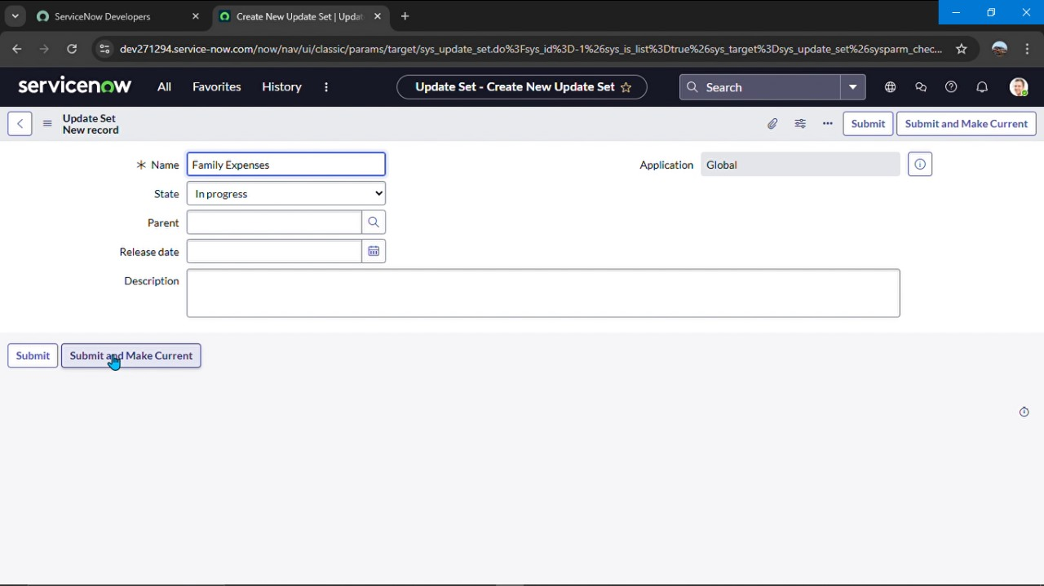

**ACTIVITY 2 : CREATION OF TABLE**

**Creation of new update set**

**1.Go to all > search for Local update set**

**2. Click new**

**3. Deatil = name – family expenses**

**4.Submit and make current**



**ACTIVITY 3 : CREATION TABLE**

**Creation of family expense table**

1. **Go to All > In the filter search for Tables >**

**Click on New.**

**Enter the Details:**

**Label : Family Expenses**

**Name : Auto-Populated**

**New menu name : Family Expenditure**

1. **Go header right click there > click save**

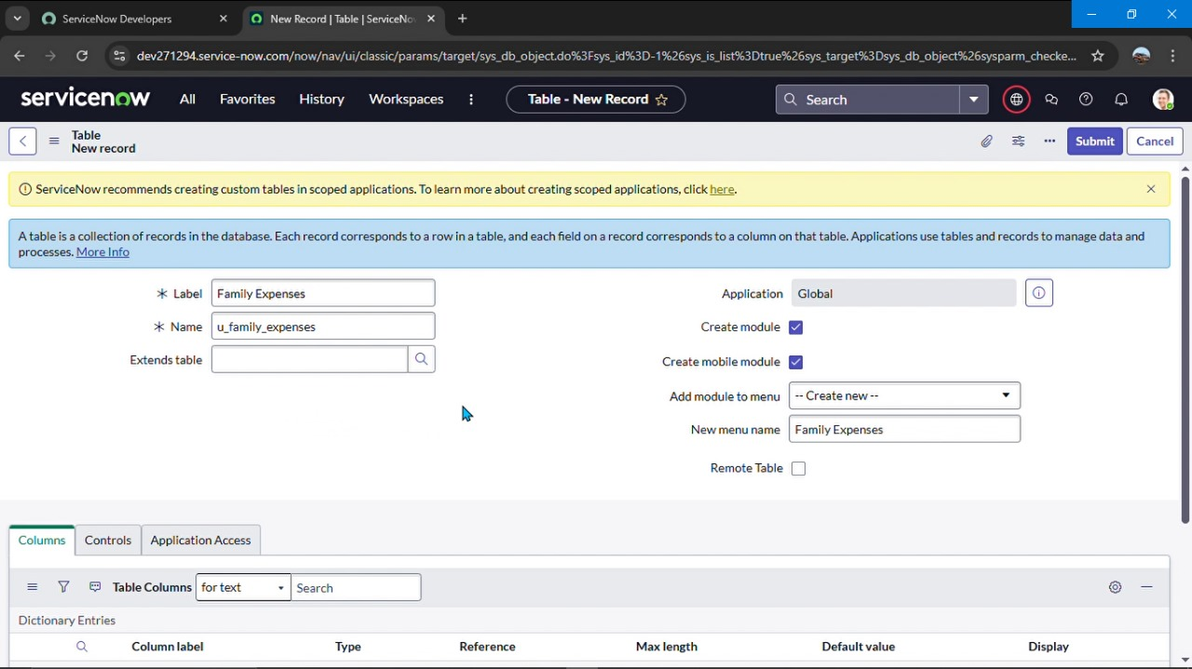

**ACTIVITY 4 : CREATION OF COLUMNS (FIELDS)**

**Column label : Number**

**Type : String**

**Double click on insert a new row again**

**Give the details as:**

**Column label : Date**

**Type : Date**

**Double click on insert a new row again**

**Give the details as:**

**Column label : Amount**

**Type : Integer**

**Double click on insert a new row again**

**Give the details as:**

**Column label : Expense Details**

**Type : String**

**Max length : 800**

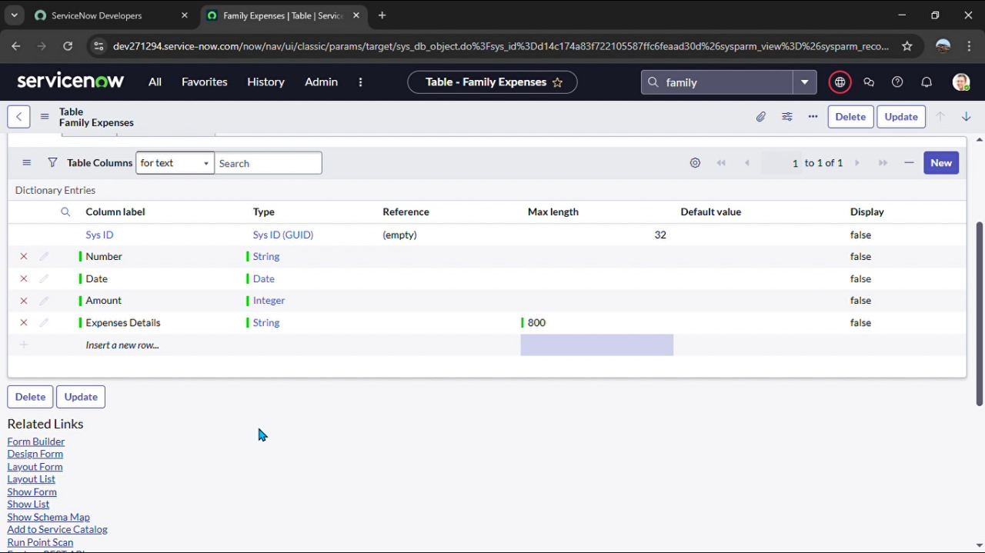

**ACTIVITY 5 : CONFIGURE THE FORM**

**Go all > search family expenses**

**Click new**

**Header configure select form design**

**Make date , amount, mandatory**

**Click on save button.**

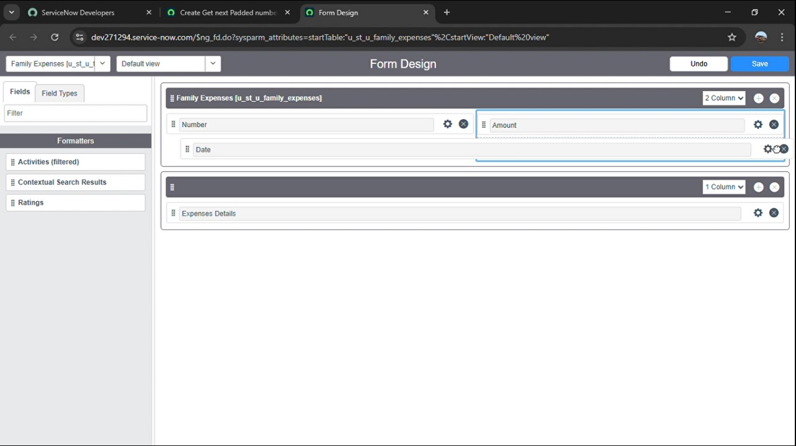

**ACTIVITY 6 : CREATION OF DAILY EXPENSES TABLE**

**Go all > search tables**

**Details : daily expenses**

**Name : auto populated**

**Click right there and save.**

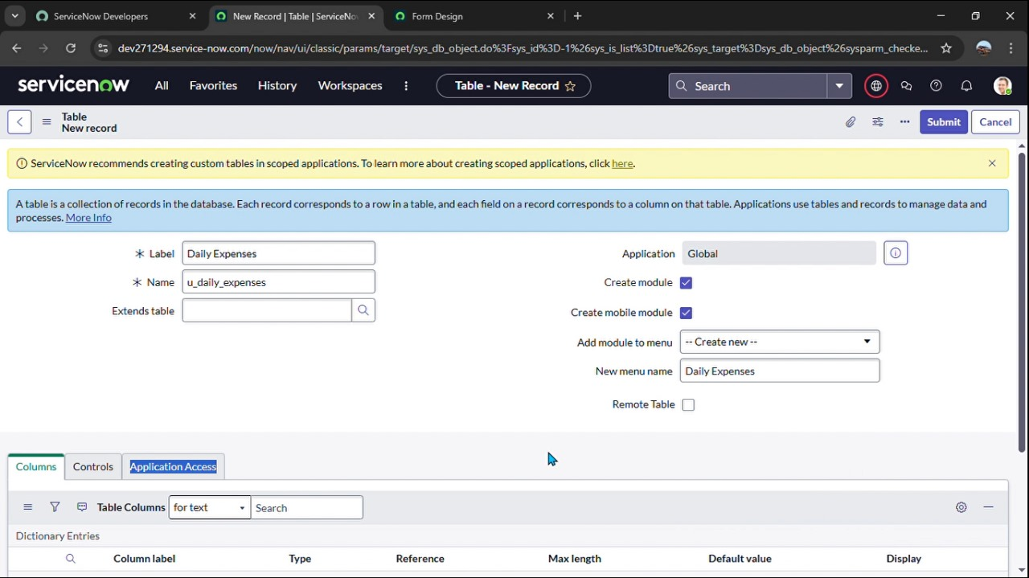



**ACTIVITY 7 : CREATION OF BUSINESS RULES**

**Go all > search Business rules**

**Detail name : family expenses BR**

**Table : daily expenses**

**When to run check insert and update**

**Then type code**

**Go to header and right click there >> click on**

**Save.**

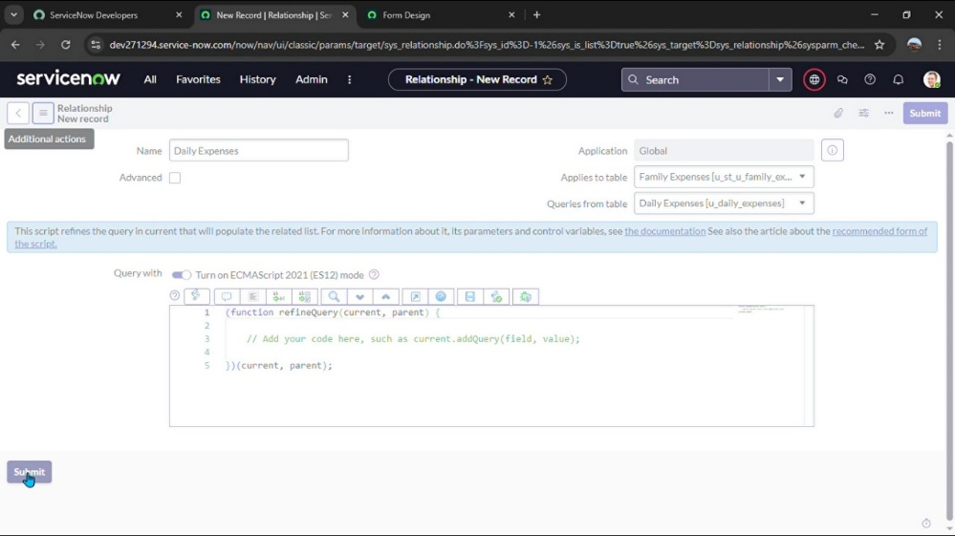

**ACTIVITY 8 : CONFIGURE OF RELATIONSHIP**

**Go all > search Business rules**

**Detail name : family expenses BR**

**Table : daily expenses**

**When to run check insert and update**

**Then type code**

**Go to header and right click there >> click on**

**Save**

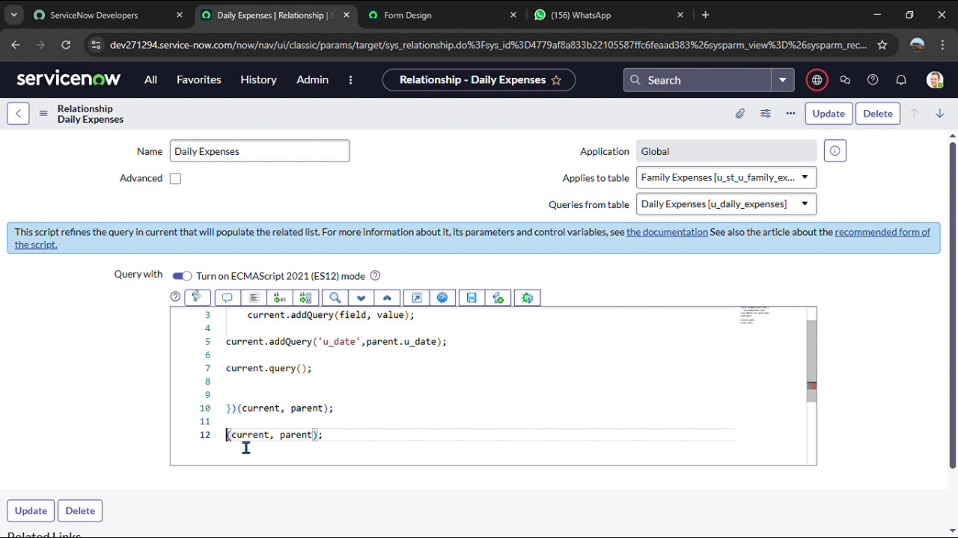

**CONCLUSION**

**Using ServiceNow to track family expenses streamlines budgeting**

**Through automation and clear reporting. It helps families monitor spending,**

**Improve financial planning, and make informed decisions more efficiently**